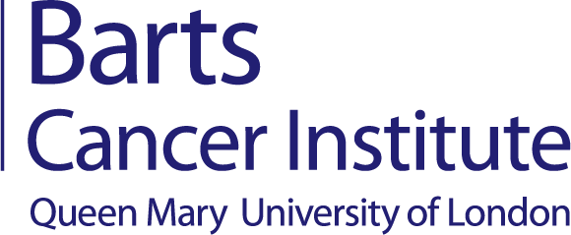
Induction Schedule 2024-25
MRes Translational Biomedical Sciences
Tuesday 17th September 2024 | The Octagon  Queens Building, Mile End Campus E1 4NS
14:45-15:00 | ID Card Collection  CLICK HERE FOR INFORMATION
Wednesday 18th September 2024 | Barts Cancer Institute  Charterhouse Square Campus EC1M 6BQ
09:30 | Registration Tea/Coffee  On Campus: Lister & Young/Ian Hart
10:00 | Welcome to Barts Cancer Institute and Induction Orientation  Professor Andrejs Braun, Teaching Office  On Campus: Lister & Young/Ian Hart
10:30 | Programme Induction with Programme Director  MRes Translational Biomedical Sciences  Dr Katiuscia Bianchi & Prof John Marshall  Location: G.07
12:00 | Lunch Break  Lister & Young/Ian Hart
13:00 | Meet the Teaching Centre Team  QM+, MySIS, Mentorship, Tips for Success  Teaching Office  On Campus: Lister & Young/Ian Hart
14:00 | Barts Cancer Research Society Information Session  Graduates of BCI 2024  On Campus: Lister & Young/Ian Hart
14:15 | QMPlus Guidance Session  Hazel Church, Digital Learning Officer  On Campus: Lister & Young/Ian Hart
15:00 | Social: Trip to Centre of the Cell  On Campus: Whitechapel Campus
Thursday 19th September 2024 | Barts Cancer Institute  Charterhouse Square Campus EC1M 6BQ
10:00 | Workshop Sign-Up - Tea/Coffee  On Campus: Lister & Young/Ian Hart
10:30 | Assessment and Extenuating Circumstance Guidance  Ellis Murrell, Academic Coordinator  On Campus: Lister & Young/Ian Hart
11:30 | Library Resources Session  FMD Library Team  On Campus: Lister & Young/Ian Hart
12:00 | Lunch Break  Lister & Young/Ian Hart
Workshops
13:00 | CANM907 Biological Therapies  Dr Oliver Pearce and Prof Fran Balkwill  On Campus: G.05
13:45 | Tour 2
14:30 | Social Space  On Campus: G.06
16:00 | Refreshments/Social Gathering  On Campus: Lister & Young/Ian Hart

